In Partnership with Asia Academic Experience, LLC

Vietnam and Bhutan
OCT 2-18, 2022

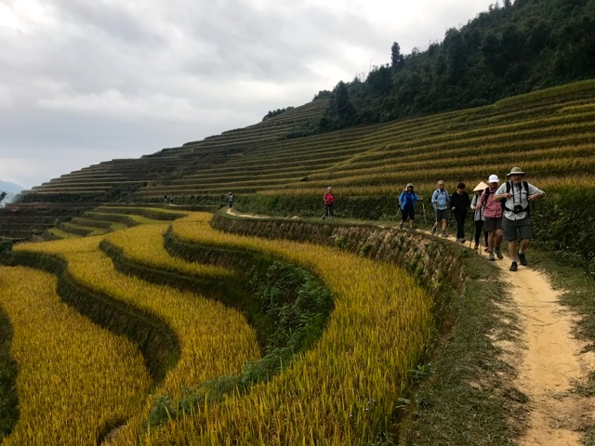

VIETNAM
Please consider this itinerary a general roadmap for the places we will visit and the activities involved. As on all our tours, we leave room for “serendipity” so we can take advantage of unique people, places and events.

Sept 30: Participants are leaving the US no later than Sept 30th, so as to arrive in Danang by the end of the day on October 1.
--If you want a “recovery day” before the tour starts, you would fly on the 29th, and arrive the evening of the 30th. The cost of the hotel that night is not expensive, and will be charged separately.
--Otherwise, you would fly on the 30th, and arrive on the evening of Oct. 1. Shuttles will pick up at the Danang airport on the nights of the 30th and 1st for the 45 min ride to Hoi An.

Transportation for this tour is by passenger coach, (two passenger vans in the Vietnam mountains), flight from Dong Hoi to Hanoi, by boat for some of the tours, by flight between Hanoi and Bangkok, and round trip Bangkok-Paro, Bhutan. All of this transportation is included in the tour fee, including transfers from airports. Participants pay for their flights from their home airport to Da Nang, Vietnam, and from Bangkok back to their home airport.

Meals are noted by (B, L, D) each day in Vietnam. Breakfast is included every day and our hotels usually have lovely buffet breakfasts that include both Asian and American food.
All meals are included in Bhutan.

September 30, October 1st
Airport pick-up of participants and transfer to Hoi An Rosemary Hotel 4* (www.hoianrosemary.com/)

Sunday, October 2: Danang/Hoi An (B, D)
We will try to have a short meeting most days before we head out—or we will preview the day and answer your questions on the bus or at the hotel the day before.

This first day we will meet after breakfast at 9:00am for a short orientation, and then will take a Hoi An walking tour. Our tour will include the Ancient Town, home to the beautiful Chua Cau or roofed bridge, the ancient meeting places, as well as lovely hidden pagodas.

Lunch is on your own in the Old City. Free afternoon for shopping, massage and/or beach. A nap may in order for some of us!

Our welcome dinner will be at 7 pm in Hoi An. Afterwards we will discuss books that each of us has read, and share any books that people have brought along.

Monday, October 3: Hoi An & Hue (B, L)
After breakfast, our luggage will be collected and stored and we will check out of the hotel.

A morning bike ride (or scooter bike taxis for those who don’t want to bike) takes us to Cam Thanh fishing village to go net fishing, then crab fishing on round bamboo boats with native fishermen. Around noon, we will have a cooking class at Cam Thanh village, followed by a lunch featuring some of the food we have prepared. Finally, those who want a foot massage can have one before our 2 pm departure.

Our bus will take us to Hue, approximately 2 ½ hours with a stop in Danang at the famous China Beach and an overview of the city from Marble Mountain. The Marine base in Danang is still operational.
Our overnight is at the Anna Mandara Resort, (https://anamandarahue-resort.com/en_US), for two nights.
Dinner is on your own; the hotel restaurant is said to be great.

Tuesday, October 4: Hue (B, L, D)
After breakfast and a short meeting, we will leave at 8:30 for a complete tour of Hue, the Vietnamese capital during the Nguyen Dynasty (1802-1945) and a well-known World Cultural Heritage Site. The Citadel and Imperial City still contain ruins of the city’s regal past, including seven royal tombs built by the emperors themselves. We will view the Thien Mu pagoda (the oldest and most symbolic pagoda in Hue) and the royal tombs via a cruise along the Perfume River. We will also have visits to Minh Mang and Khai Dinh tombs, which are the most beautiful tombs among the royal tombs in Hue.

Lunch is at Biet Phu Thao Nhi restaurant. Afternoon is on your own.

Group dinner. Either before or after dinner there will be a one-hour group discussion about the book “Eaves of Heaven,” an excellent portrayal of three major time periods in Vietnam’s history.

Wednesday, October 5: Quang Binh (B, L)
After we enjoy an early breakfast, we’ll check out of our hotel and put our luggage on the bus. Our morning meeting will be on the bus. We will stop at the DMZ, which is a significant historical site if you are interested in the Vietnam War (which, in Viet Nam, is called “The American War”). The Vietnamese Demilitarized Zone (DMZ) was established as a dividing line between North and South Vietnam as a result of the First Indochina War.

After a 3-hour bus drive on the Ho Chi Minh trail to Dong Hoi town in Quang Binh province, we will have a wonderful lunch at the Lake House Restaurant. The afternoon will provide time to explore the area around Paradise Cave, an incredible and colorful cave. Deep in the national park, surrounded by forest and karst peaks, this remarkable cave system is truly breathtaking, as wooden staircases descend into a cathedral-like space replete with colossal stalagmites and glimmering stalactites of white crystal that resemble glass pillars.

Around 4:00 we will head to the airport for our flight from Dong Hoi to Hanoi, (6-7:00 pm) where we will stay at the Grand Cititel Hotel. https://www.cititels.com/grand-cititel-hanoi-hotel
Dinner is on your own--since the hotel is in a great location, there will be many choices.

Thursday October 6: Trang An National Park, and back to Hanoi. (B, L, D)
After breakfast, we will go to Trang An National Park, for your choices of biking, walking, kayaking, and sightseeing at this unique and beautiful park, about an hour from Hanoi. You can make your choices of activities during the ride to the park. Upon our return to Hanoi, you have free time with several choices: a performance at the Water Puppet Theater (1/2 hour show, tickets are $3.00), (to view one of the traditional Vietnamese art forms), shopping, or people watching at the lake.

Our group dinner will be at 7 pm, followed by a short walk to the famous Hoan Kiem Lake, which is very picturesque when lit up after dark.

Friday, October 7: Hanoi-Ha Long Bay (B, L, D)
After breakfast and a meeting, we will leave at 9:30 am to drive to Hai Phong city, less than two hours away, at the launching spot for cruises in Ha Long Bay. As you know, this whole area is a UNESCO World Heritage Site.

We will check in for our 1 ½ day cruise. http://www.peonycruises.com/. Read the detailed itinerary for the two day, one night cruise. Smile at the unique descriptions of our activities.
There will be opportunities for swimming, kayaking, and exploring before a sunset happy hour, a lovely seafood dinner, and optional squid fishing or relaxation on the top deck of our boat. We will have a discussion about your reflections so far, either during happy hour or after dinner.

Saturday, October 8: Ha Long & Lao Cai (B, L)
Morning Tai chi is offered on our boat, before breakfast. We will have a chance to hike on one of the islands to caves and views of the whole bay from the famous Cat Ba National Park. After lunch, we will check out and transfer to two smaller vans for our trip to the mountainous regions north of Hanoi. We will take breaks, but it is perhaps a good day to catch up on your reading or sleep, as the trip will take at least 6 hours and our destination is Bac Ha, to the Cong Fu Hotel-Bac Ha.
Dinner will be on your own—local restaurants are within walking distance so you can stretch your legs!

Sunday October 9: Bac Ha (B, L, D)
Today is such a special day! We plan the entire itinerary so that we can attend the unforgettable Sunday market in Bac Ha town. This weekly market is famous in all of SE Asia for the originality and authenticity that the traders still preserve. It is a blur of colorful plaids and stripes from women of many different ethnic tribes. There is also a buffalo market and auctions!

After the market ends, and a quick lunch, our buses head to Pan Hou resort (5 hour drive). Although these two days have long drives, the Bac Ha market is truly a remarkable experience, and the Pan Hou resort is a lovely eco-lodge close to one of the most fascinating hikes we will take.

The group will experience an amazing dinner and overnight in bamboo-walled “cabins” at the Pan Hou resort (www.panhou-village.com/en) (along with good wifi in the lodge/bar)

Monday, October 10: (B, L, D)
Today is our long trek in Vietnam, at the Suoi Thau-Luoc village—a hike of approximately 8 miles up and down small hills. Lunch is along the way, then we’ll head back to Panhou for late afternoon relaxing, learning about this eco-lodge, our Luther-sponsored happy hour, and dinner. It’s a great place for us to gather to reflect, talk about other books each of us has enjoyed, and/or review our hiking accomplishment.
A second overnight at Pan Hou Resort (www.panhou-village.com/en)

Tuesday, October 11: (B, L, D)
We’ll leave fairly early after breakfast for our 6-hour bus drive back to Hanoi, with lunch on the road.
Our overnight is again at the Grand Cititel Hotel. People watching and shopping will be your reward after the long bus day.

We’ll enjoy our group dinner, our last in Vietnam, at one of the many excellent restaurants in the Old City. Either before or after, we’ll have a meeting/gathering where we can discuss the transition from Hanoi to Bangkok to Bhutan, reflect on the past 10 days and look forward to the next set of adventures.

Wednesday, October 12: (B, L)
After breakfast and hotel check out, is a Hanoi city tour (including the Ho Chi Minh Mausoleum, Presidential Palace, HCM house, Temple of Literature, Hanoi Hilton). We need to leave for the airport after lunch for our 4:00 pm flight to Bangkok (BKK).

Our Bangkok hotel, Cottage Suvarnabhumi, (https://www.thecottagebangkokairport.com) is near the airport, and we should arrive early enough so you can explore the nearby area and have dinner on your own.

BHUTAN
All 3 meals each day are included in Bhutan.

Thursday, October 13: Bangkok- Bhutan, Day 1
Our flight leaves early, but it gives us more time on our first day in Bhutan!

Paro - Thimphu (65kms/1.5hrs)
Paro (alt. 2200m/7218ft) - The beautiful valley of Paro encapsulates within itself a rich culture, scenic beauty and hundreds of myths and legends. It is home to many of Bhutan's oldest temples and monasteries, National Museum and country's only airport. Mt. Chomolhari (7,314m/23,996 ft.) reigns in white glory at the northern end of the valley and its glacial water plunge through deep gorges to form Pa Chhu (Paro River). Paro is also one of the most fertile valleys in the Kingdom producing a bulk of the locally famous red rice from its terraced fields.

The flight to Paro is considered one of the most spectacular flight experiences in the world. While flying in and out of Bhutan, one can see Mt. Everest, Kanchenjunga, Makula, and other high peaks such as Jmalhari, Jichu Drakey, and Tsrim Gang. We will meet our Bhutanese guide, and get our visas.

After landing at Paro, our tour guide will take us on a short one and half hour drive along the Paro and Thimphu river valleys to Thimphu, Bhutan’s capital, at 2320 meters/7611 ft.
After checking into our hotel, we will visit the following major sights.

Buddha point
Built in 2006, the world’s largest sitting Buddha houses over hundreds of thousands of small statues inside. The paintings and statues inside the monument provide a deep insight into Buddhist philosophy. Enjoy a stunning view of Thimphu city from this point.

Memorial Chorten
Built in 1974 as a monument for the 3rd king of Bhutan Jigme Dorji Wangchuck. It signifies the “Seat of Faith” and “Mind of Buddha”. It is also an informal “senior day care” for the elders of this city.

Tashichho Dzong
This interesting set of buildings has been the seat of the government since 1952 and presently houses the throne room and offices of the king, the secretariat and the ministries of home affairs and finance. Other government departments are housed in buildings nearby.

After dinner you are free to explore Thimphu Town and the Bhutanese Authentic Local Crafts Bazaar.

October 14: Bhutan Day 2, Thimphu
After breakfast we will go by bus 15km out of town to hike to Cheri Monastery. This one hour+ hike is uphill going up to the Monastery.

It was established in 1620 by Zhabdrung Ngawang Namgyal. The monastery is now a major teaching and retreat center of the Southern Drukpa Kagyu sect. The Monastery serves as the monastic school for study of Buddhist philosophy, metaphysics, mathematics, poetry and many other Buddhist studies. According to legend and part of the history of Bhutan, the place was first visited by Padmasambhava in the 8th century. In the 13th century it was visited by Phajo Drugom Zhigpo, the Tibetan Lama who first established the Drukpa Kagyu tradition in Bhutan. Zhabdrung spent three years in strict retreat at the monastery and stayed for many years after those three years.
A delicious lunch will be provided at the riverside. After lunch we will drive back to the city and visit:

School of Thirteen Arts & Crafts
It is the primary center of learning for Bhutanese artists. Depending upon the student’s interest, one can specialize in any of the thirteen arts and crafts, including painting, weaving, sculptures, blacksmithing, embroidery, etc. It is the best place for visitors to learn about traditional Bhutanese arts and crafts.

National Textile Museum
This museum is worth a visit to learn about Bhutan's living national art of weaving. The ground floor focuses on cham costumes, while the upper floor introduces the major weaving techniques, styles of local dress and type of textiles made by women and men. There is usually a small group of weavers working their looms inside the shop, which features work from the renowned weaving centre of Lhuentse in northeastern Bhutan.

Centenary Farmer’s Market
Take a walk through this market and shop/interact with the local farmers. Thimphu’s new weekend market is by far the largest domestic market for the farmers in Bhutan. Farmers come from all over the country to sell their farm products in the market. With its wide assortment of fresh, organic produce, the Farmer’s Market has become a favorite spot for tourists and a recreational place for people from all walks of life. Overnight is in Thimphu, same hotel. We will have an optional book discussion about the recommended Bhutan books. The exact book will be communicated on the reading list.

October 15, Bhutan day 3, Thimphu – Punakha
After breakfast we will drive to Punakha.
Punakha Altitude: 1300m/4265ft. Punakha served as the capital of Bhutan during the time of Zhabdrun Ngawang Namkgyal, the founder of Bhutan. Today it is the administrative and religious center of the district and the winter home of Bhutan’s Central Monk Body. It is blessed with temperate climate and owing to its natural drainage from Pho Chhu (male) and Mo Chhu (female) rivers, the Punakha valley produces abundant crops and fruits.

Start your morning by enjoying and taking pictures of the Dochula Pass (3150m/10,334ft) with its panoramic views of the Himalayas. The pass is decorated with 108 Druk Wangyel Chorten, which were built to celebrate the stability and progress, brought to Bhutan by His Majesty Jigme Singye Wangchuck, the Fourth King of Bhutan. The pass provides a spectacular 360-degree panoramic view of the Himalayan Mountain Range.

After checking into our Punakha hotel we will visit the following places, with a stop for lunch along the way:

Chimmi Lhakhang
Situated on a hillock in the center of the valley, this place is dedicated to Lama Drukpa Kuenley, who in the late 15th century used humor, songs and outrageous behavior to dramatize his teachings and due to this he is also known as "Divine Madman". It is known as a fertile temple area, and is frequented by childless couples and others alike for blessings.
On our way from this fascinating area, we will visit a local farmhouse for tea and treats, while we experience the hospitality of a Bhutanese host.

Punakha Dzong
This name means Palace of Great Bliss. This Dzong stands magnificently on the spit of land where two rivers (Phochu and Mochu) meet. Punakha Dzong has special significance in Bhutanese history as the place where Bhutan's first King, Ugyen Wangchuck, was crowned in 1907.

Suspension Bridge
This Bridge is located near Punakha Dzong and is the longest suspension bridge in Bhutan. The bridge connecting the nearby villages and mountains adjacent gives us a magnificent view.

In the late afternoon, we have free time to explore Punakha Town and/or relax at the hotel. We will have a Luther sponsored happy hour that evening, before dinner. There will be an optional discussion about what we have seen and learned in Bhutan, at our halfway point.

October 16: Bhutan day 4, Punakha-Paro
After breakfast our bus will take us back to Paro. Enroute we may visit the Lamperi Botanical Gardens - The garden is located in the center of a 47 sq. mile botanical park (35km from Thimphu) and has over 46 species of rhododendron.

After arrival and checking into our lovely hotel, we will visit the following places:

National Museum (Ta Dzong)
This dzong was built in the 17th century to guard the Paro Rimpong Dzong (fortress) below. It was said that the future first king was kept in this tower as a prisoner for a week. It was the third king who restored the Ta-dzong and converted it into the National Museum. The visit to the museum will familiarize you with the Bhutanese way of life and will also acquaint you with the natural and cultural history.

Paro Rimpong Dzong
Regal and imposing, dzongs are arguably among the most distinctive and important structures in Bhutan. This Dzong is the headquarters of the Paro district, housing the head administrator and staff, as well as a monastic body with about 200 monks. From the dzong, we will hike down to the bridge and then take a short drive for an opportunity to explore the town of Paro.

After our incredible buffet dinner, the evening is free.

October 17: Bhutan Day 5, Paro
Bhutan’s most picturesque landmark, Taktshang, the Tiger’s Nest, clings to the side of a steep cliff (300m/984 ft.) above the Paro valley. The place was first visited by Guru Rimpoche, founder of the tantric form of Buddhism in Himalayan countries, in the 8th century. It was said that he meditated there for about three months. The original temple was built in the 17th century, but tragically, it was consumed by fire in 1998. Like a phoenix, the temple was rebuilt to its fullest glory in 2003. Takshang is considered to be the 10th holiest site in the Buddhist world.
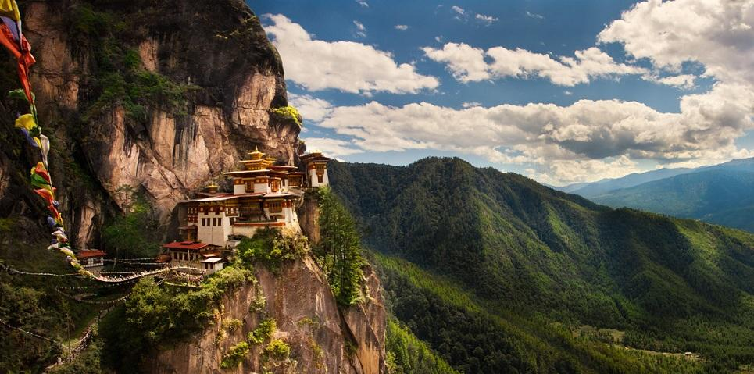

The hike is strenuous, but well worth the effort! The eight mile (rd. trip) hike takes approximately four hours, depending on the length of your break about half-way up for tea and crackers and on how many photos you take! The tea house is also a good spot to stop and wait for the others, if you choose not to continue to the top.

Later in the afternoon you have options:
Visit Kyichu Lhakhang, one of the oldest and most sacred shrines of the Kingdom dating back to 7th century (the other is Jambey Lhakahng in Bumthang). The Lhakhang complex is composed of two temples. The first temple was built by Tibetan King, Songtsen Gampo in the 7th century and in 1968, H.M. Ashi Kesang, the Queen Mother of Bhutan, built the second temple in the original pattern.

Or, Visit arts and crafts shops in Paro

Or, relax at the hotel

Our final gathering will include another wonderful buffet dinner at the Naksei Resort, after which we will have a final session to share our impressions of Bhutan, and say our goodbyes.

October 18, Bhutan Day 6: Fly out of Bhutan to Bangkok. Either flight gets us to BKK by late afternoon. From there, you are welcome to travel to other places on your way home, or stay for a few days in Thailand, Laos, or elsewhere.

Note from Ann and Jerry: We plan to spend 4-5 days in Laos at the end of the Luther tour. Participants are welcome to join us, but we will need to know as soon as possible about your interest. It’s the only SE Asian country that we haven’t visited, and we will do much of the planning ourselves.

Program Highlights
- 17 nights accommodation in first-class (3.5–4-star) hotels with private bathrooms; some have pools, all are clean, comfortable, and in great locations.
- Daily breakfast, most lunches, and 6 group dinners (see itinerary for exact meals) in Vietnam; all meals in Bhutan
- All transportation within and between the two countries: one flight from Hanoi to Bangkok, a short flight in Vietnam, a round trip flight between Bangkok and Paro, Bhutan, and all motorcoaches, vans, and boats.
- Comprehensive guided sightseeing and activities, including all applicable entrance fees.
- Your visa fee in Bhutan ($40)
- Tour manager, group leaders, and in-country guides to accompany the group.
- All taxes and most gratuities on included services, including hotel personnel, guides and drivers in Vietnam.

NOT INCLUDED:
- Round trip flight from your home to Danang, Vietnam, and home from Bangkok, Thailand.
- Alcoholic beverages at meals, (the exceptions are the Luther sponsored happy hours mentioned in the itinerary).
- Vietnam Visa fee of $25/person, which you will obtain in advance, on-line. We will send complete instructions on how to do that.
- There is an expectation that each person will tip the guide and bus driver in Bhutan, recommended amount to be communicated next fall. (approximately $8-10 for each of 6 days for bus drive and our guide—both are with us the entire time we are in Bhutan)
- Shopping expenses and other personal expenditures.
Travel Documents
For international travel, all U.S. citizens must have a current passport with 6-month validity remaining after your return date. We will assist participants in the forms and processes necessary for visas to each country; both countries allow purchase of the visa in advance; (VN visa will be completed on-line 4-6 weeks in advance, for $25, Bhutan’s visa is included in your fee and will be awaiting our arrival in Paro). Vietnam and Bhutan both have their own currency.
You will receive a thorough and complete Travel Handbook approximately 2 months before departure.

We will be looking at costs as soon as we know numbers of participants. The cost will be as close to $4300 for double rooms (single supplement of almost $900) as possible, accounting for hotel and air costs, etc.

